**Design of Rhombic Microstrip Antenna for UWB Applications**

D. Prabhakar1 , N. Sai Prathyusha2, R. Gopi Raju2 , Mani. Ch2 , Y. Naga Pavan2

1Associate professor, Department of ECE, Gudlavalleru Engineering College (A), Seshadri Rao Knowledge Village, Gudlavalleru, Andhra Pradesh, India,

[prabhakar.dudla@gmail.com](mailto:prabhakar.dudla@gmail.com)

2B.tech student, Department of ECE, Gudlavalleru Engineering College (A), Seshadri Rao Knowledge Village, Gudlavalleru, Andhra Pradesh, India,

### [nimmagaddasaiprathyusha@gmail.com](mailto:nimmagaddasaiprathyusha@gmail.com) , [rajolugopiraju156@gmail.com](mailto:rajolugopiraju156@gmail.com) , [manichallapallli1967@gmail.com](mailto:manichallapallli1967@gmail.com) ,

**ABSTRACT**

In this paper an Ultra-Wideband (UWB) microstrip antenna consisting of a Rhombic monopole patch with stepped feed line, with a 10 dB return loss bandwidth from 1.99 to 12.31 GHz is proposed. This antenna was designed on ROGERS 5880 substrate with overall size of 30 X 20 X 1.6 mm3 and dielectric substrate with 𝜀𝑟 = 2.2 This antenna operated at UWB frequency and it designed by using Ansys HFSS (High Frequency structure simulator) Software based on the characteristic impedance for the transmission line model. The parameters like substrate dimension, feed size and ground plane which affect the performance of the antenna in terms of its frequency domain and time domain characteristics are investigated. The variations of different antenna parameters are compared between use of Copper and Graphene as the patch material.

Keywords: Microstrip line feed, microstrip antenna, Wireless systems, Ultra-Wide Band, Copper, Graphene, ROGERS 5880, Ansys HFSS

1. **INTRODUCTION**

Many antennas are employed for various wireless applications nowadays. The growing popularity of wireless systems has attracted many researchers to work in this area. This gave rise to exponential increase in the interest of many researchers and innovators working in UWB domain and thus increase of research work in RF design. Circuit design. System design for microwave transmission. The microstrip antenna has become the most preferred antenna because of low-cost and simple fabrication approach. The antenna consisting of copper material as patch and ground provides the minimum return loss of (<-10dB) at any corresponding resonant frequency, but the results of these copper is not satisfactory for various parameters as the conductivity of copper is less. In this paper, copper and graphene are used as patch and ground materials in each of the cases and compared for desirable return loss, gain, and bandwidth for operation in Ultra-Wide Band (UWB). Due to their broad range of applications, Ultra-Wideband antennas are sought after in both academia and industrial fields. This UWB ranges from 3.1 GHz to 10.6 GHz frequency. The applications of these UWB antennas include-

a) Communications

b) RADAR

c) Precision Geolocation

ROGERS 5880 was chosen as the substrate material for its flexibility and durability. The antenna was simulated using Ansys HFSS (High-Frequency Structure simulator). The designed antenna has a bandwidth of more than 10 GHz. The proposed antenna is also designed to obey the SAR limit of 1.6 W/Kg acceptable limits of SAR (Specific absorption rate) for biomedical applications. Hence, the antenna can be used for on-body communications.

In recent times antennas are employed in an increased number of applications. These include communication, biomedical, and even industrial purposes. This paper discusses about the design of Rhombic shaped microstrip antenna using copper and graphene as patch, ground and feedline materials. Properties of these materials are discussed in the forthcoming sections. The substrate used is Rogers 5880. The RT/duroid has random glass micro-fiber structure and is less anisotropic. The dissipation factor is less so it has low electrical signal losses than that of FR4 material. By varying the ground structure, the required parameters like antenna gain, bandwidth, directivity and return loss are examined. The radiation box used is assigned medium of vaccum. The radiation box should have at least quarter wavelength in the embedding medium (usually a vacuum) between the closest radiating edge and the closest edge of the box, at the lowest frequency (typically dimensions around 20mm*20mm*1.6mm). This paper aims for providing an antenna which covers a maximum bandwidth in UWB including a minimum specific absorption rate. Dimensions including length and width of the substrate, slit, feedline, patch, corner slot and rectangular slot are considered in designing of the antenna. By varying the dimensions of the feedline, ground and introducing stepped feedline the bandwidth is increased considerably.

1. **ANTENNA GEOMETRY AND SIMULATION RESULTS**

By using the antenna design equations, the important parameters of a patch like width, actual length, feedline length and slot dimensions are calculated.

The geometry of the proposed antenna is shown in Figure 1. The corresponding dimensions of patch are listed in Table 1.

The same dimensions are used to generate an antenna with defected ground structure. Figure 2 shows the bottom view of the antenna having the ground plane. The semi-circular ring slit in the ground has a width of 0.1 mm and the corners of the ground are shorted to enhance the bandwidth of the microstrip patch antenna. The dimensions corresponding to the ground plane are listed in Table 2.

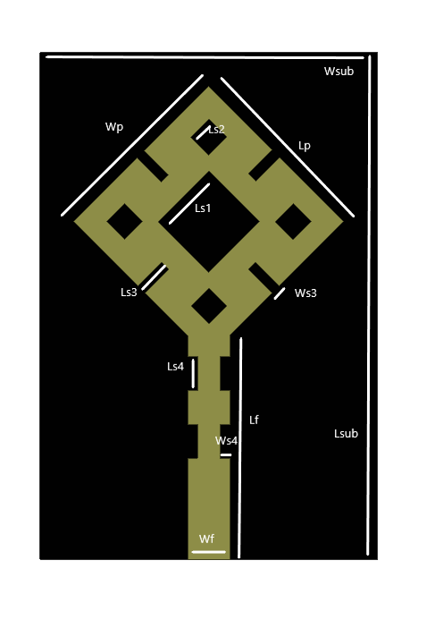 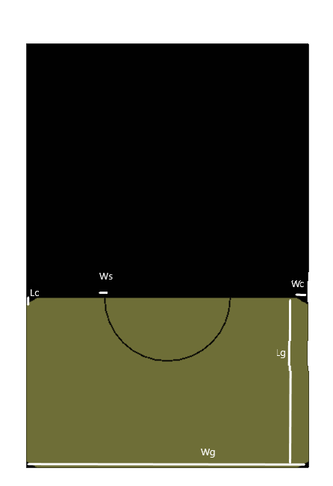

**Figure 1 & 2:** Antenna Front view with patch and back view with ground plane.

**Table 1:** Dimensions of patch Antenna.

|  |  |  |  |
| --- | --- | --- | --- |
| **Design Parameter** | **Dimensions(mm)** | **Design Parameter** | **Dimensions(mm)** |
| Length of the substrate Lsub | 30 | Width of the feedline Wf | 2.5 |
| Width of the substrate Wsub | 20 | Length of feedline Lf | 9 |
| Width of the slit on patch Ws3 | 0.6 | Length & Width of inner slot Ls1 | 4.24 |
| Length of the slit on feedline & patch Ls3, Ls4 | 2 | Width of the slit on feedline & patch Ws3, Ws4 | 0.6 |
| Width & Length of smaller slot on patch Ls2 | 1.5 | Width & Length of the patch Lp, Wp | 11.31 |
| Thickness of the substrate | 1.6 |  | |

**Table 2:** Dimensions corresponding to ground plane.

|  |  |
| --- | --- |
| **Design Parameter** | **Dimensions(mm)** |
| Width of corner slots on ground Wc | 0.75 |
| Width of the ground Wg | 20 |
| Width of the semi-circular ring slit in ground Ws | 0.1 |
| Length of corner slots on ground Lc | 0.433 |
| Length of the ground Lg | 12 |

The performance of the designed Rhombic shaped microstrip patch antenna using ROGERS 5880 is analysed using both copper and graphene as patch materials and the results are compared and documented to understand the variations in different antenna parameters with change of patch material from copper to graphene.

The results obtained with copper patch are as follows:

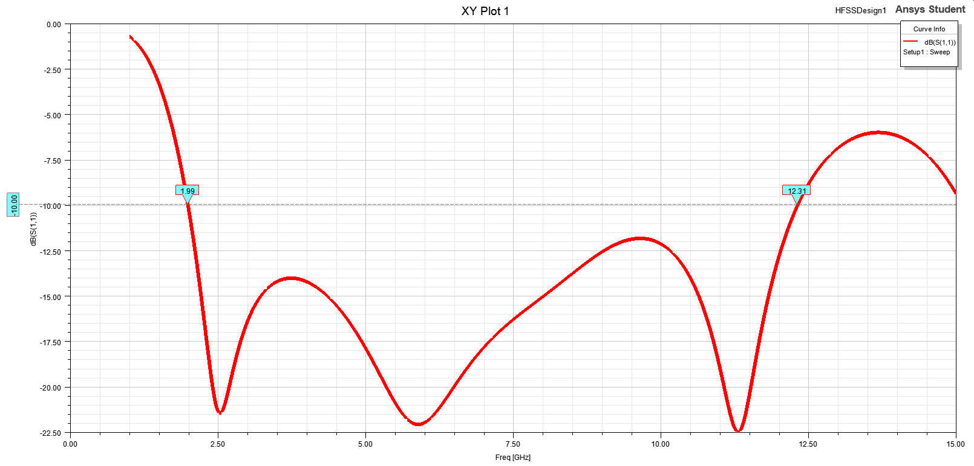

**Fig 3:** S11(in dB) of designed antenna with copper patch.

It is observed that from the obtained results as shown in figure 3, the bandwidth of the copper patch antenna is from 1.99 GHz to 12.31 GHz. The above figure gives the scattering parameter S11 (in dB) vs frequency (in GHz) graph for the designed rhombic shaped antenna.

The Voltage standing wave ratio, VSWR (in dB) vs frequency plot of the same antenna with copper patch can be observed in below figure 4

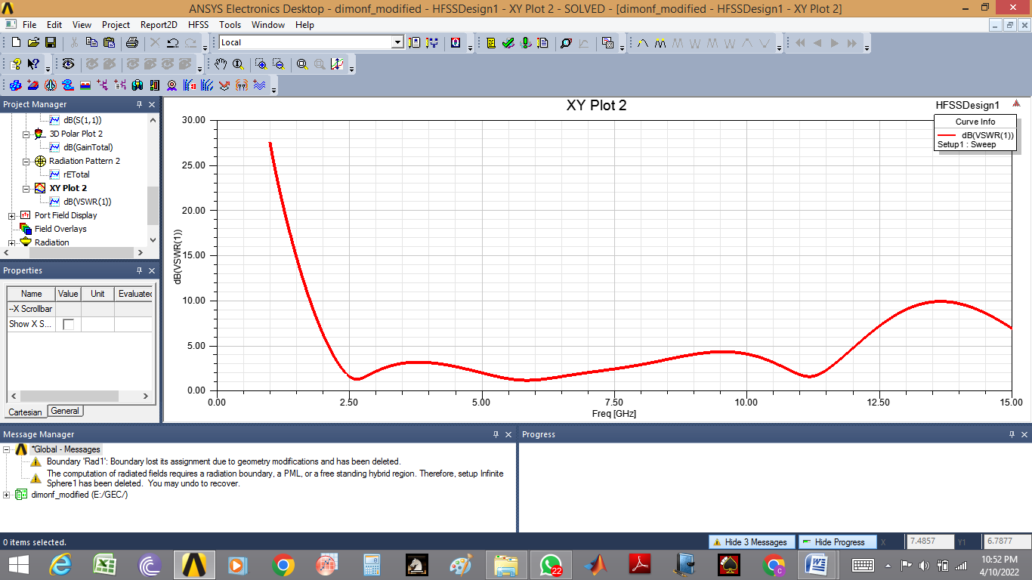

**Fig 4:** VSWR (in dB) of designed antenna with copper patch.

The 3D plot of Total Gain (in dB) for the designed rhombic shaped antenna can be observed in the figure 5.

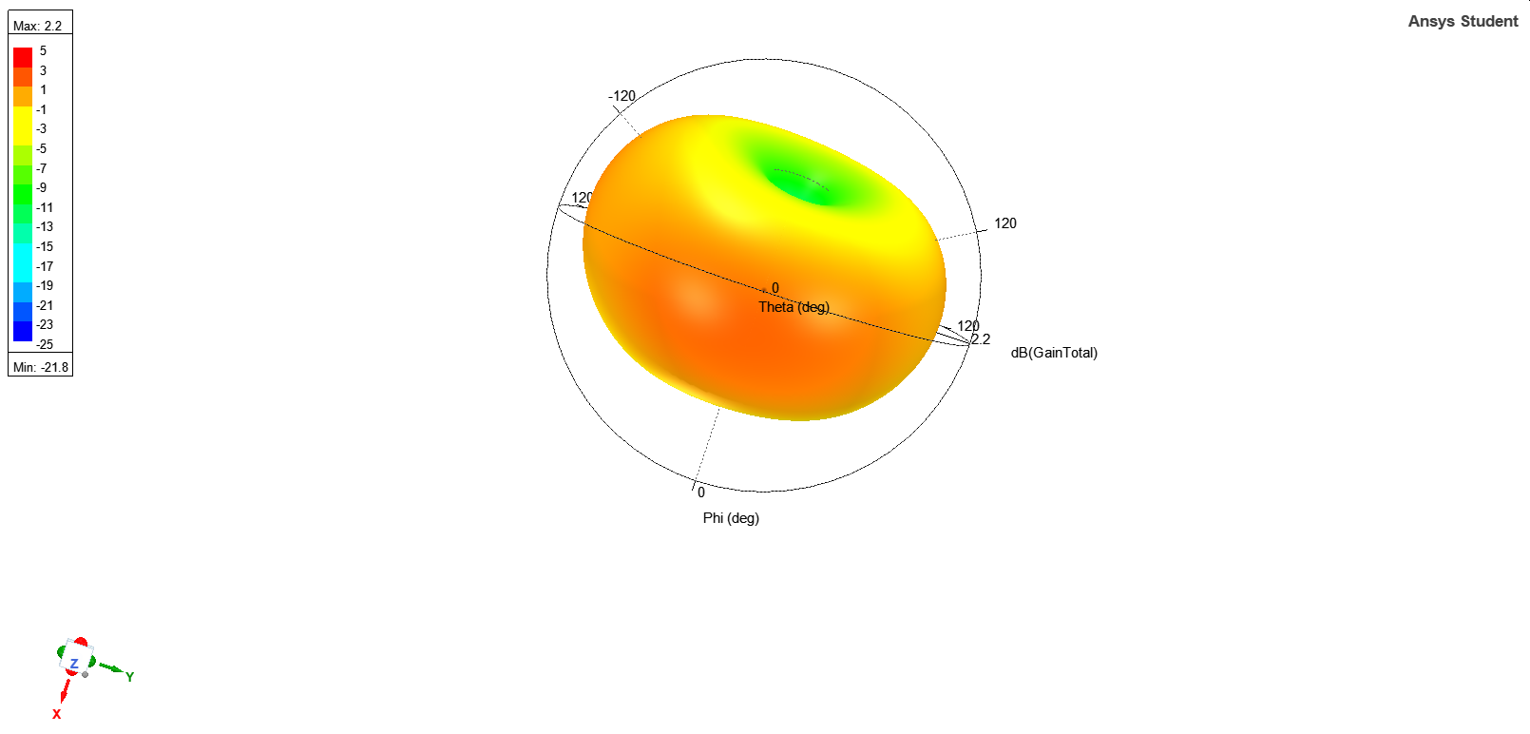

**Fig 5:** 3D plot of Total Gain (in dB) with copper patch.

The polar plot showing the Radiation pattern for the designed rhombic shaped antenna with copper patch can be observed in the figure 6.

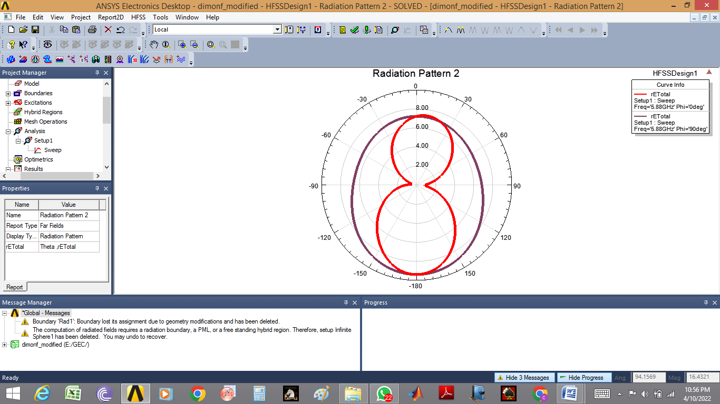

**Fig 6:** Polar plot of radiation pattern with copper patch.

The results obtained with Graphene patch are as follows:

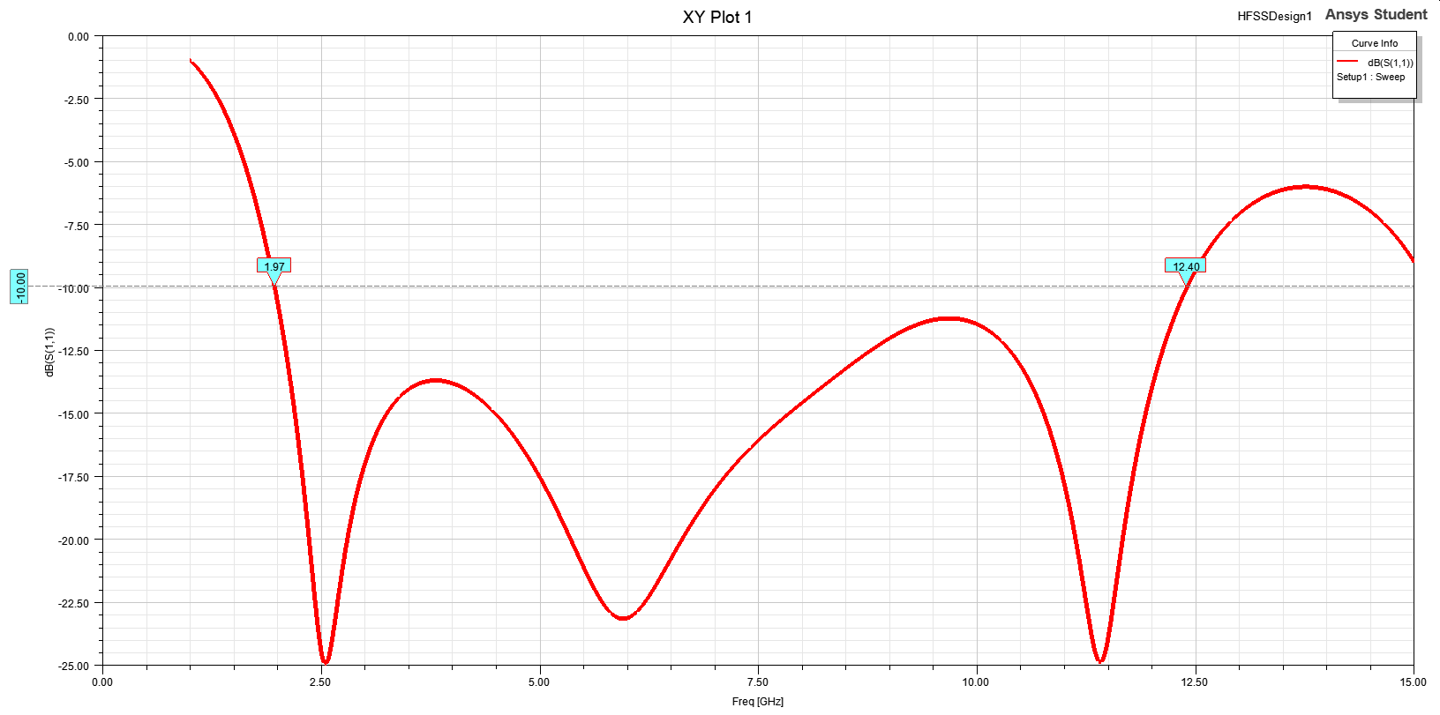

**Fig 7:** S11(in dB) of designed antenna with graphene patch.

It is observed that from the obtained results as shown in figure 7, the bandwidth of the copper patch antenna is from 1.97 GHz to 12.40 GHz. The above figure gives the scattering parameter S11 (in dB) vs frequency (in GHz) graph for the designed rhombic shaped antenna. By comparing with the copper patch, we can observe an increase in the bandwidth of about 110 MHz

The Voltage standing wave ratio, VSWR (in dB) vs frequency plot of the same antenna with copper patch can be observed in below figure 8

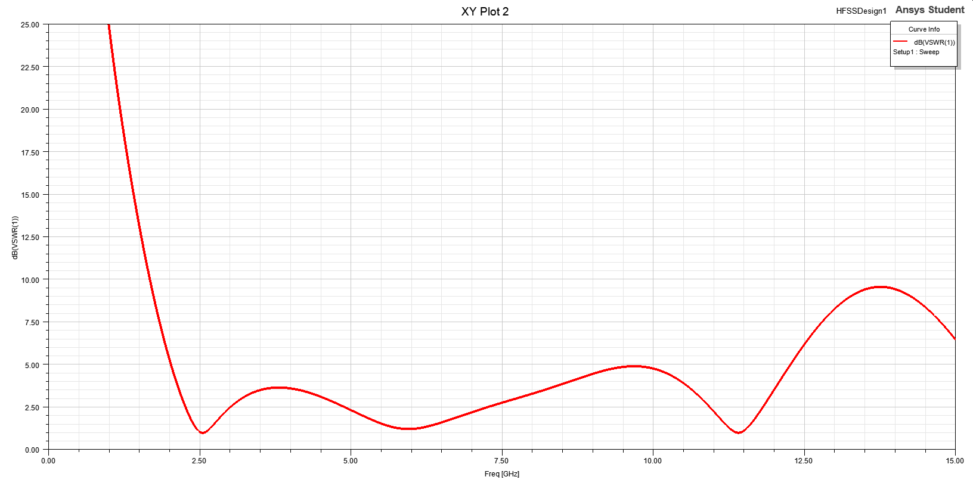

**Fig 8:** VSWR (in dB) of designed antenna with graphene patch.

The 3D plot of Total Gain (in dB) for the designed rhombic shaped antenna can be observed in the figure 9.

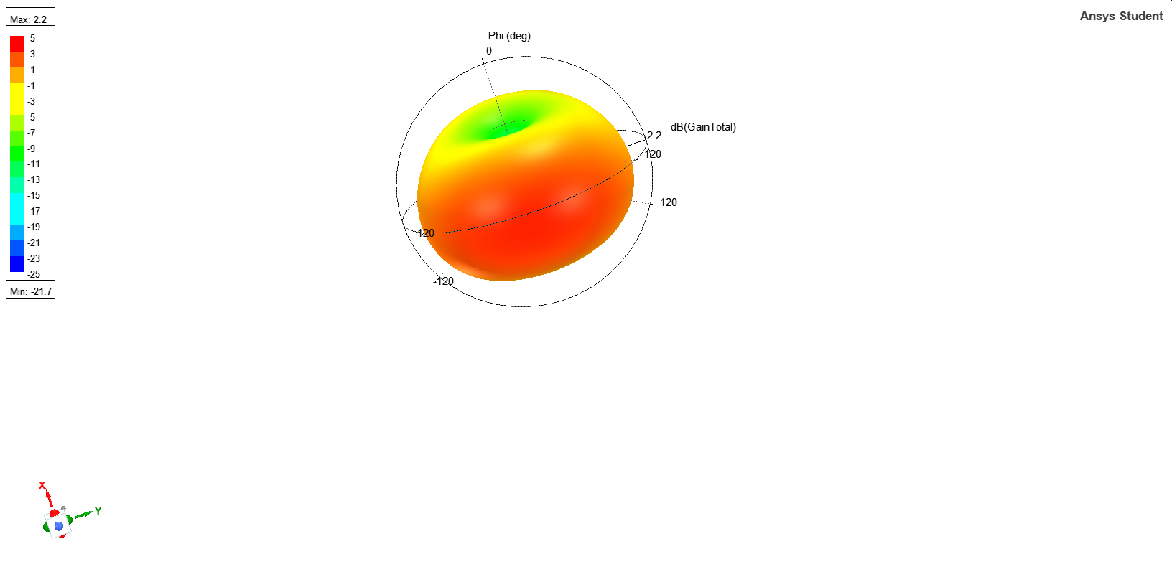

**Fig 9:** 3D plot of Total Gain (in dB) with graphene patch.

The polar plot showing the Radiation pattern for the designed rhombic shaped antenna with graphene patch can be observed in the figure 10.

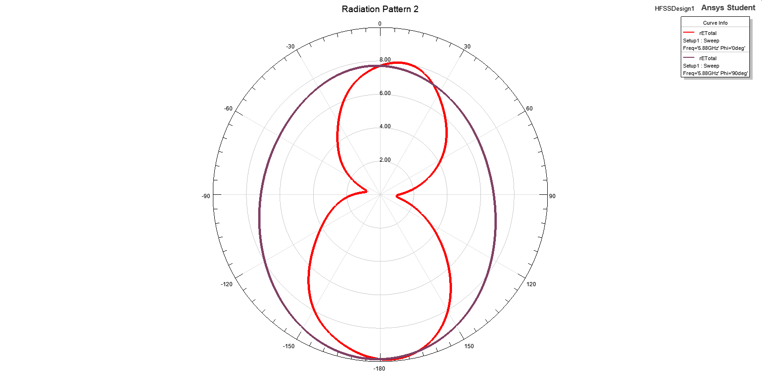

**Fig 10:** Polar plot of radiation pattern with copper patch.

1. **RESULTS AND DISCUSSION**

The individual results obtained after simulation of both copper and graphene patches in HFSS software are used to compare different antenna parameters like VSWR (Voltage standing wave ratio), Scattering parameter (S11), Total Directivity and Total Gain using MATLAB.

The plots obtained can be used to arrive at conclusions on the effect of the patch material on different antenna parameters in Ultra-wide band frequency range. All the comparisons are done in the frequency range of 1 GHz to 15 GHz for uniformity in the plots drawn using MATLAB.

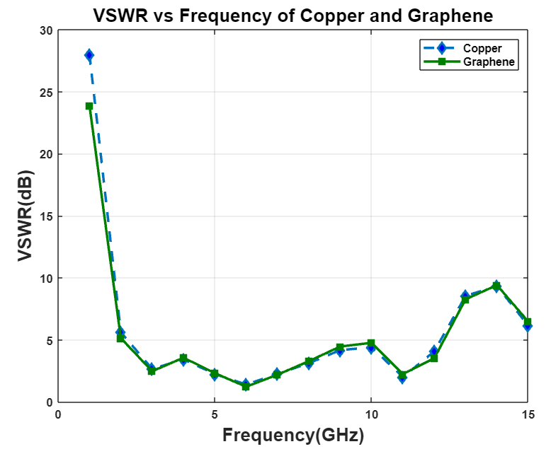

**Fig 11:** Comparison plot of VSWR (in dB) for Copper and Graphene antenna.

In the above comparison plot it can be observed that maximum VSWR of 28.00 dB and 23.89 dB are obtained at 1 GHz for copper and graphene respectively.

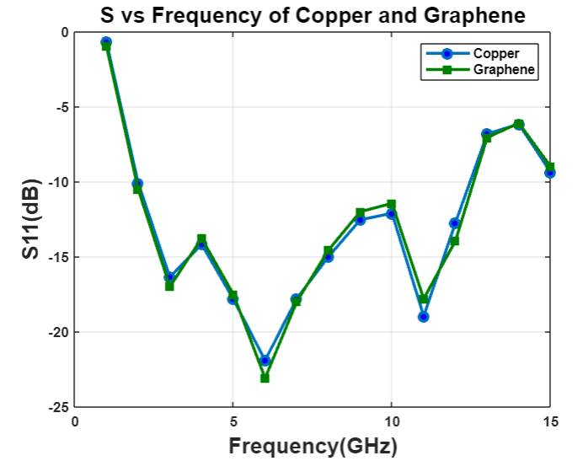

**Fig 12:** Comparison plot of S11 (in dB) for Copper and Graphene antenna.

In the comparison plot drawn for S11(in dB) against frequency for both copper and graphene, it can be observed that maximum S11 scattering parameter of -0.69 dB and -0.98 dB are obtained at 1 GHz for copper and graphene respectively.

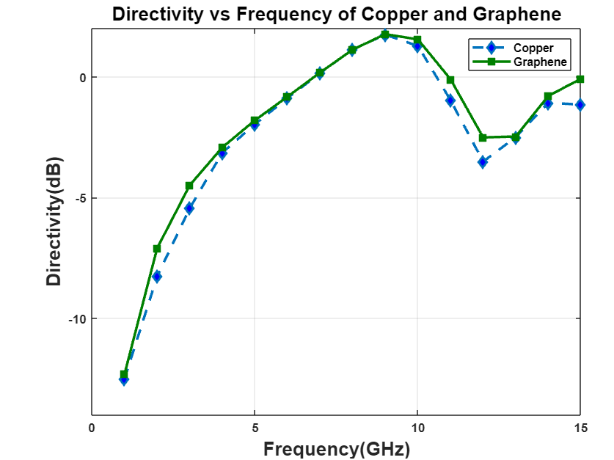

**Fig 13:** Comparison plot of Directivity (in dB) for Copper and Graphene antenna.

In the above comparison plot for Directivity (in dB) against frequency, it can be observed that maximum Directivity of 1.75 dB and 1.77 dB are obtained at 9 GHz for copper and graphene respectively.

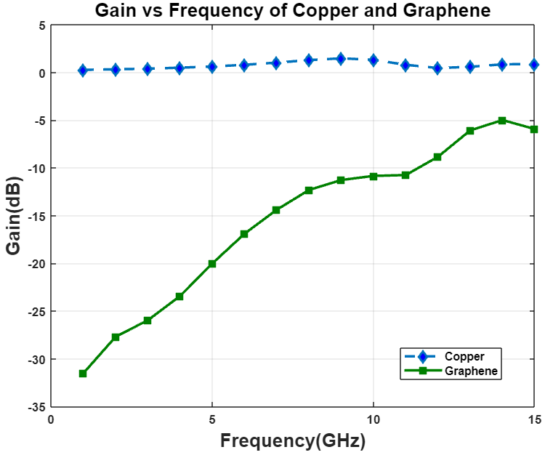

**Fig 14:** Comparison plot of Gain (in dB) for Copper and Graphene antenna.

In the above comparison plot for Gain (in dB) against frequency, it can be observed that maximum Directivity of 1.47 dB at 9 GHz and -4.98 dB at 14 GHz are obtained for copper and graphene respectively.

1. **CONCLUSION**

Even though the ground patch is most popularly made of Perfect Electric Conductor (PEC), various parametric results demonstrate that graphene patch gives a lower reflection coefficient (S11) and VSWR, as well as superior directivity, when compared to copper patch. There is also an increase of around 110 MHz bandwidth for Graphene when compared to Copper. As a result, graphene coated patches could be a high performing substitute for copper conductive patches.

**REFERENCES**

1. LitonChandra Paul, Nahid Sultan, “Design, Simulation and Performance Analysis of a Line Feed Rectangular Micro-Strip Patch Antenna”, International Journal of Engineering Sciences & Emerging Technologies, Volume 4, Issue 2, February 2013, ISSN: 2231-6804.
2. R. K. Tanti, S. Warathe and N. Anvesh Kumar, "Design of a Circular Planar UWB Antenna and its Higher Cut-off Frequency Enhancement," 2019 10th International Conference on Computing, Communication and Networking Technologies (ICCCNT), 2019, pp. 1-6, doi:10.1109/ICCCNT45670.2019.8944570.
3. K. N. Paracha et al., "A Low Profile, Dual-band, Dual Polarized Antenna for Indoor/Outdoor Wearable Application," in IEEE Access, vol. 7, pp. 33277-33288, 2019, DOI: 10.1109/ACCESS.2019.2894330.
4. T. Huynh and K. F. Lee, "Single-Layer Single-Patch Wideband Microstrip Antenna, " Electronics Lett. , vol. 31, no.16, pp. 1310- 1312, August 1995.
5. S. W. Su, K. L. Wong, and F. S. Chang, "Compact Printed Ultra- Wideband Slot Antenna with a Band-notched Operation," Microwave and OpticalTechnology Lett., vol. 45,no. 2, April 2005, pp. 128-130,April 2005.
6. K. Chyng, J. Kim, and J. Choi, "Wideband Microstrip-Fed Monopole Antenna Having Frequency Band-Notch Function," IEEE Microwave and Wireless Components Lett., vol.15, no. 11, pp. 766- 768, Nov. 2005.
7. K. F. Tong, K. M. Luk, K. F. Lee, and R. Q. Lee, "A broad- band u-slot rectangular patch antenna on a microwave substrate," IEEE Trans. On Antennas and Propagation, vol. 48,no. 6, pp. 954 - 960, Jun. 2000.
8. Y. X. Guo, K. M. Luk, K. F. Lee, Y. L. Chow, "Double u-slot rectangular patch antenna," Electronics Lett., vol. 34, pp. 1805- 1806, Sep. 1998.
9. K. F. Lee, S. Yang, A. A. Kishk, "Dual and multiband u-slot patch antennas", IEEE Antennas Wireless Propagation Lett., vol. 7, pp. 645 -647, Dec. 2008
10. K. F. Lee, S. L. S. Yang, A. A. Kishk, and K. M. Luk, "The Versatile Uslot Patch Antenna, "IEEE Antennas and Propagation Magazine,” vol. 52, no. 1, pp. 71-88, Feb. 2010.
11. M. 1. 1. Ammann, M., "Some techniques to improve small ground plane printed monopole performance," in Antennas and Propagation Society International Symposium. 2007 IEEE, vol. 9
12. Hossain, 1.; Noghanian, S.; Pistorius, S.; , "A diamond shaped small planar ultra wide band (UWB) antenna for microwave Imaging Purpose," Antennas and Propagation Society International Symposium,2007 IEEE , vol., no., pp.S713-S716, 9-1S June 2007
13. Sadat, S.; .lavan, S.D.S.; Houshmand, M.; , "Design of a Microstrip square-ring slot antenna filled by an H -shape slot for UWBapplications," Antennas and Propagation Society International Symposium, 2007 IEEE , vol., no., pp.70S-708, 9-IS June 2007
14. Zhi Ning Chen, Senior Member IEEE & Terence S. P See and Xianming Qing “Small printed UWB Antenna with reduced Ground Plane effect” IEEE transactions on Antenna & Propagation Vol. 55 No. 2, February 2007